**Project DataSet**

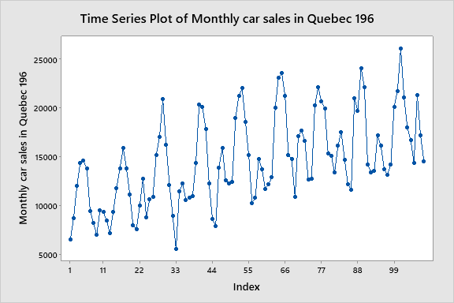

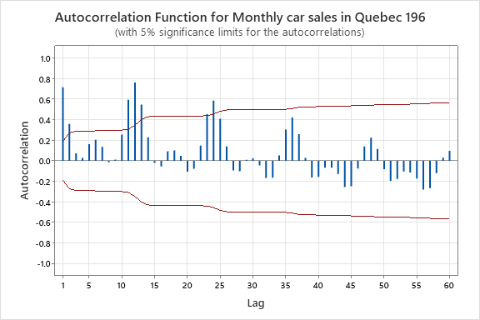

There is a Seasonal pattern.Therefore we can do a seasonal difference.

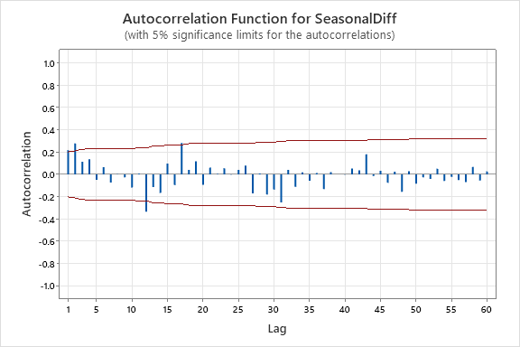

PACF

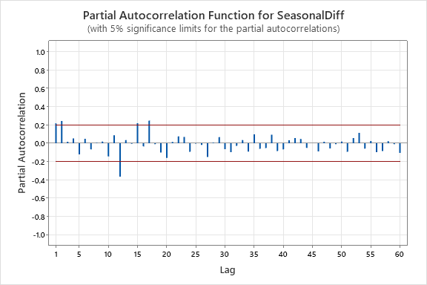

SARIMA(2,0,2)(1,1,1)